**Connect with the Azure Active Directory PowerShell for Graph module**

Commands in the Azure Active Directory PowerShell for Graph module have **AzureAD** in their cmdlet name. You can install the [Azure Active Directory PowerShell for Graph](https://docs.microsoft.com/en-us/powershell/azuread/v2/azureactivedirectory) module or [Azure PowerShell](https://docs.microsoft.com/en-us/powershell/azure/install-az-ps?view=azps-3.6.1).

For procedures that require the new cmdlets in the Azure Active Directory PowerShell for Graph module, use these steps to install the module and connect to your Microsoft 365 subscription.

### Step 1: Install required software

These steps are required once on your computer, not every time you connect. However, you'll likely need to install newer versions of the software periodically.

1. Open an elevated Windows PowerShell command prompt (run Windows PowerShell as an administrator).
2. In the **Administrator: Windows PowerShell** command window, run this command:

Install-Module -Name AzureAD

If prompted about installing a module from an untrusted repository, type **Y** and press ENTER.

### Step 2: Connect to Azure AD for your Microsoft 365 subscription

To connect to Azure AD for your Microsoft 365 subscription with an account name and password or with multi-factor authentication (MFA), run one of these commands from a Windows PowerShell command prompt (it does not have to be elevated).

|  |  |
| --- | --- |
| **Office 365 cloud** | **Command** |
| Office 365 Worldwide (+GCC) | Connect-AzureAD |
| Office 365 operated by 21 Vianet | Connect-AzureAD -AzureEnvironmentName AzureChinaCloud |
| Office 365 Germany | Connect-AzureAD -AzureEnvironmentName AzureGermanyCloud |
| Office 365 U.S. Government DoD and Office 365 U.S. Government GCC High | Connect-AzureAD -AzureEnvironmentName AzureUSGovernment |

In the **Sign into your account** dialog box, type your Microsoft 365 work or school account username and password, and then click **OK**.

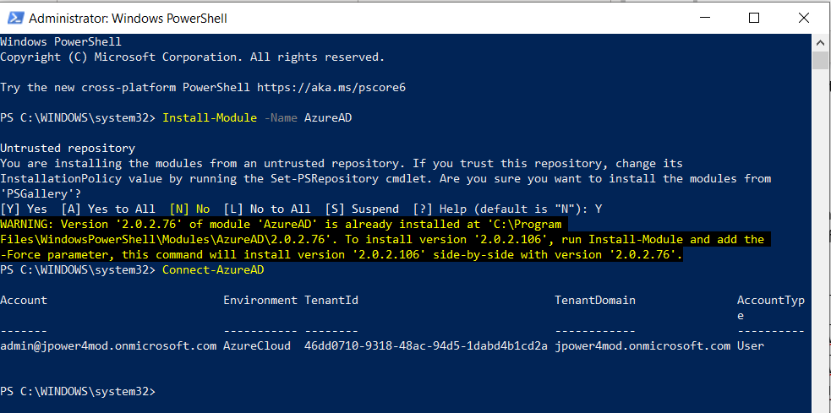

If you are using MFA, follow the instructions in the additional dialog boxes to provide more authentication information, such as a verification code.